**DAILY ONLINE ACTIVITIES SUMMARY**

|  |  |  |  |  |  |  |  |
| --- | --- | --- | --- | --- | --- | --- | --- |
| **Date:** | **28/05/20** | | | | **Name:** | **Deeena Muthappa** | |
| **Sem & Sec** | **8th sem, A sec** | | | | **USN:** | **4AL16CS028** | |
| **Online Test Summary** | | | | | | | |
| **Subject** | | **SMS** | | | | | |
| **Max. Marks** | | **60** | | **Score** | | **54** | |
| **Certification Course Summary** | | | | | | | |
| **Course** | **Introduction to Ethical Hacking** | | | | | | |
| **Certificate Provider** | | | **Great Learning** | **Duration** | | | **254 mins** |
| **Coding Challenges** | | | | | | | |
| |  | | --- | | **Problem Statement: Find last remaining element after reducing the Array** | | | | | | | | |
| **Status: Completed** | | | | | | | |
| **Uploaded the report in Github** | | | | **Yes** | | | |
| **If yes Repository name** | | | | **Deenamuthappa/Coding-Challenges** | | | |
| **Uploaded the report in slack** | | | | **Yes** | | | |

Online Test Details:

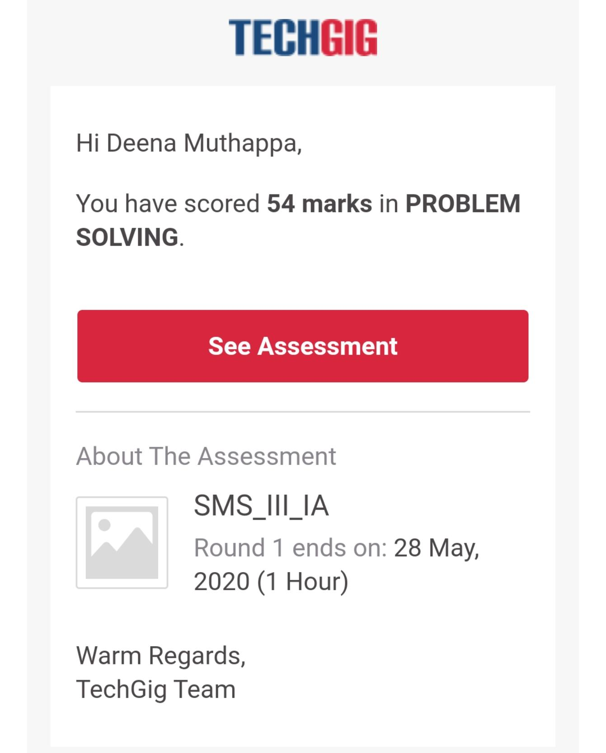

The test was on the subject System Modelling Simulation.

Certification Course Details: **COMPLETED**

Coding Challenges Details:

1) **#include <iostream>**

**using namespace std;**

**int find_value(int a[], int n, int k)**

**{**

**int sum = 0;**

**for (int i = 0; i < n; i++) {**

**sum += a[i];**

**}**

**return sum % k;**

**}**

**int main()**

**{**

**int n, k,a[20];**

**cout<<"Enter the number of element\n";**

**cin>>n;**

**cout<<"Enter the elements\n";**

**for(int i=0;i<n;i++)**

**cin>>a[i];**

**cout<<"Enter the vake of K\n";**

**cin>>k;**

**cout<<"The last remaining element : "<< find_value(a,**

**n, k)<<endl;**

**return 0;**

**}**